Semester 1 Cumulative Vocab Review Name: ______________________________

PUZZLE 1
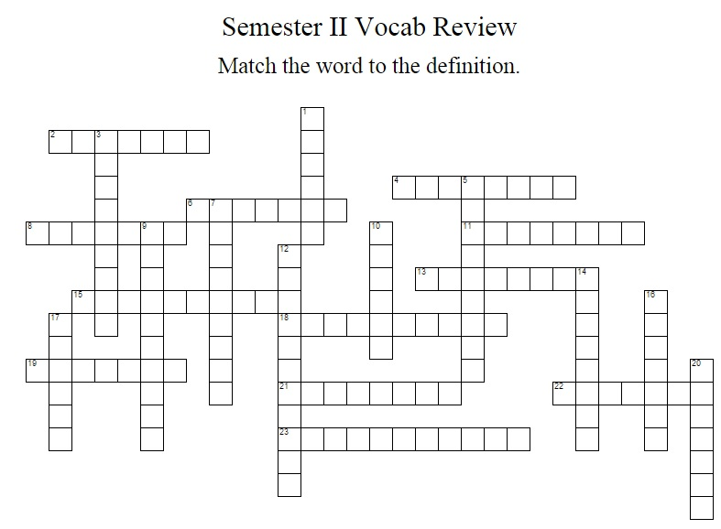

ACROSS
 |  | 2 |  | to appease; pacify; mollify; to please; to make happy
 |  | 4 |  | confirm; corroborate; support; sanction
 |  | 6 |  | to support; to reinforce
 |  | 8 |  | short and to the point; terse
 |  | 11 |  | penetrating beyond the superficial; filled with wisdom and insight; deep
 |  | 13 |  | strongly scented; fragrant
 |  | 15 |  | taking place under promising conditions; likely to succeed
 |  | 18 |  | self-satisfied; unconcerned
 |  | 19 |  | a person of great power
 |  | 21 |  | loud; full in sound; booming
 |  | 22 |  | of special quality; noble
 |  | 23 |  | undeveloped; fundamental; elementary
DOWN
 | 1 |  | small in size or amount; thin; weak
 | 3 |  | brazen; brash; nervy
 | 5 |  | rudeness; insolence
 | 7 |  | stubborn; refusing to be persuaded
 | 9 |  | coiled; twisted; winding
 | 10 |  | hopelessly ineffective; useless; in vain
 | 12 |  | misunderstand; interpret correctly
 | 14 |  | quiet
 | 16 |  | tending to avoid giving direct answers
 | 17 |  | someone with extreme enthusiasm for a particular activity or belief
 | 20 |  | to spread to every part

