Name:___________________________________
Reliable Sources Review
- Define a reliable source.

_____________________________________________________________________________

_____________________________________________________________________________

- TRUE or FALSE Most newspaper articles are reliable.

- TRUE or FALSE Primary source documents are not usually reliable sources.

- TRUE or FALSE Wikipedia is reliable.

- TRUE or FALSE .com websites are always unreliable.

- See several snapshots from a webpage below. Is the webpage below a reliable web source? Yes No

Give two reasons why it is or is not.

a.______________________________________________________________________

b. ______________________________________________________________________

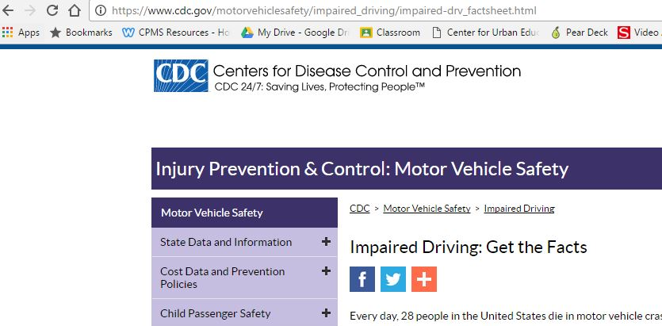

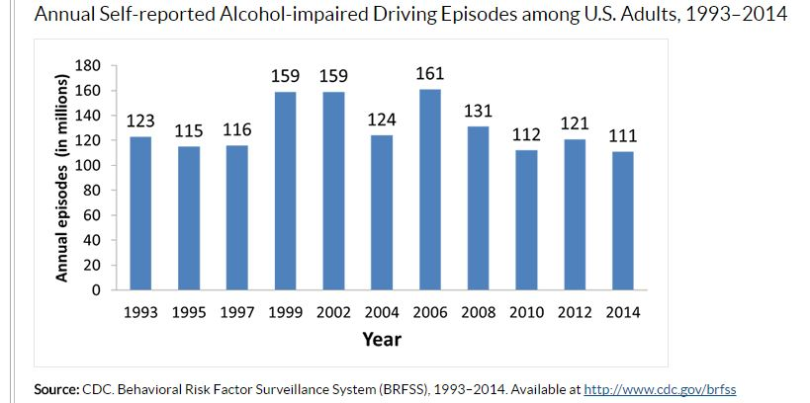

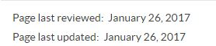

- If you were researching chicken nuggets, which of the following sources would be reliable. Circle all that are reliable.
