Name: _______________________________ _____/15

____1. Loaded language A. An appeal to emotion
____2. Slippery slope B. Convinces people to “follow the crowd”
____3. Generalization C. Uses negative words or labels to create dislike for a competitor’s idea or product
____4. Ethos D. An appeal to logic
____5. Name Calling E. Uses a respected person or someone with experience to validate the product or cause
____6. Bandwagon F. An appeal to ethics
____7. Logos G. Convinces people to make assumptions about a whole group based on just a few examples
____8. Testimonial H. Uses cause and effect to create an emotional response
____9. Pathos I. Uses words that cause strong feelings or emotional respon

Part Two: Identify the type of Persuasive Technique being utilized in images below
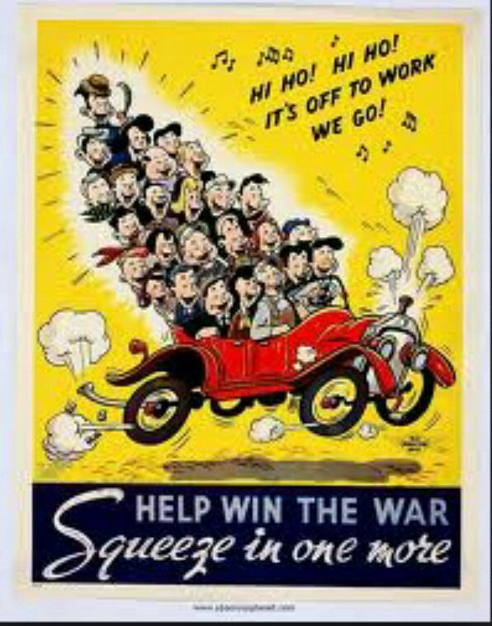
10.
This image utilizes the _______________________ technique.

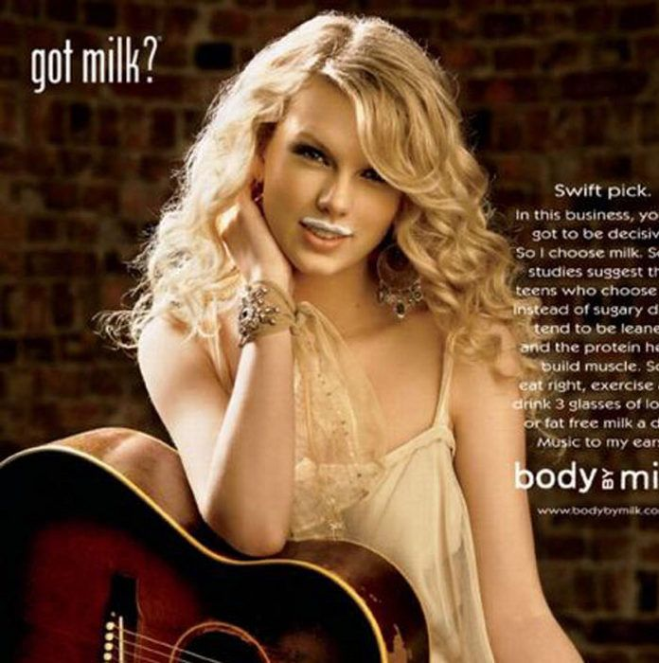
11.
This image utilizes the _______________________ technique.

(Taylor Swift )

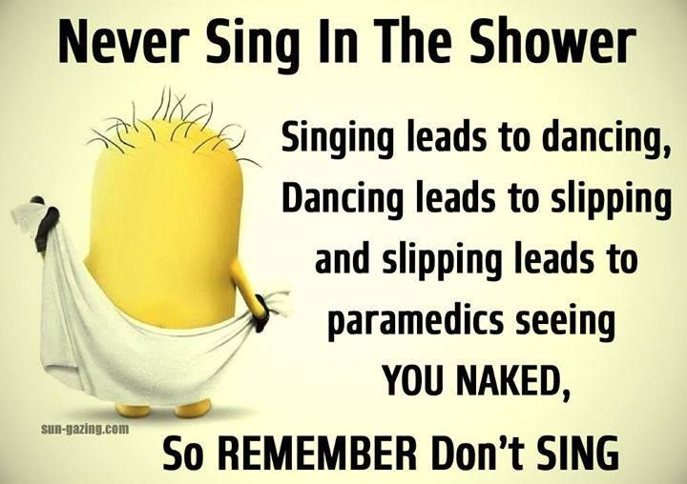
12.
This image utilizes the _______________________ technique.

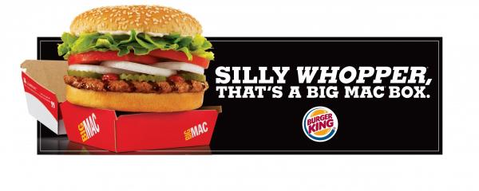
13.

This image utilizes the _______________________ technique.

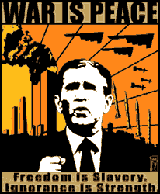
14.

This image utilizes the _______________________ technique.

15.
This image utilizes the _______________________ technique.

