30 Book Challenge
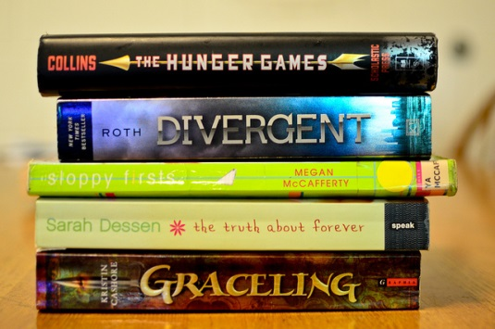

The Challenge!!
Throughout the course of the school year, I plan to read 30 books and challenge you to do the same! 30 books sounds like a lot of books, but you are capable of accomplishing this goal. The 30 book challenge is going to open your eyes to a wide variety of literary genres and will hopefully foster within you an appreciation, if not a love, for reading. In the chart below, you will find that I have provided lots of choice for your book selections; after all, the most important thing is to choose books that interest you. You will have some time in language arts class to read, and may find time in other classes to read, so ALWAYS have your book in ALL of your classes. This is a BIG challenge that will be an amazing accomplishment at the end of the year!

A Few Facts …
- The 30 Book challenge goes from August through May.
- The 30 Book Challenge is completed on the honor system, so as you complete each book you will come and tell me and I will sign off for you on your Genre Check-off List (I will also check your reading log throughout the year).
- Books exceeding 300 pages may be considered as two books for that genre.
- A maximum of five graphic novels may be counted toward your 30 books.
- All books must be at grade level or above.

30 Book Challenge Chart Name: _______________
Block: ______________

Your Choice | Poetry/Verse  Book | Autobiography/Biography | SciFi/  Dystopian | Realistic Fiction | Your Choice
Your Choice | Fantasy | Autobiography/Biography | SciFi/  Dystopian | Realistic  Fiction | Your Choice
Your Choice | Graphic  Novel | Nonfiction | Sharon Draper Novel | Historical  Fiction | Your Choice
Your Choice | Favorite Author/Series | Nonfiction | Hoosier  Author | YHBA Novel | Your Choice
Your Choice | Your Choice | Your Choice | Your Choice | Your Choice | Your Choice

- Keep this chart in the SSR section of your binder.
- Rate the book by filling in the stars - 5 is awesome, 1 star is just OK.
- After you have read a book, write the title in the correct genre, and then have Mrs. Toole sign your chart.
- Be sure to share your progress!!! Prizes will be awarded at the 10 book, 20 book, and 30 book levels!!!
- Remember, this is a personal challenge and making a goal to read more than you did last year is what matters the most

