Inferences: An Introduction Name: _________________________________

- Inference: _____________________________________________________________________________
  - You do this by combining what you learn, or ________________________________, with your __________________________________

For example:
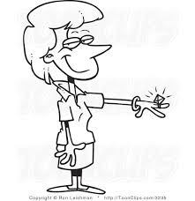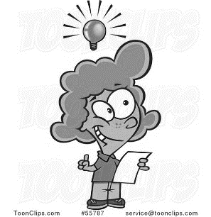
Prior Knowledge:
My sister has been dating her boyfriend for 3 years. Women often get diamond rings when they get engaged.
Inference:
My sister is engaged.
New Information:
My sister came home from a date with a diamond ring on her finger.

+ =

For example: (You try!)

Inference:

New Information:
You walk into the classroom and see an answer sheet on everyone’s desk.
Prior Knowledge:
You’ve been learning about a particular subject for weeks now, and the teacher always puts an answer sheet on desks right before a test.

+ =

- Practice:
Try to complete the following examples. Can you infer where the person is located?
Inference:

Prior Knowledge:

New Information:
I hear a loud “Thwack!” as an object soars across the sky, and the crowd roars with cheers!
Inference:

Prior Knowledge:

New Information:
I see bubbles rising. I hear my own breathing. There are fish swimming above me. I feel the seaweed swaying.

- Practice:
Complete the following examples.

What can you infer about Danielle’s mother?
Statement: After Danielle broke the vase, her mother turned and walked away without saying anything and had
a frown on her face.
Infer: ____________________________________________________________________________________
__________________________________________________________________________________________
__________________________________________________________________________________________

What can you infer about what has just happened?
Statement: I hear a loud rumble then bang outside as my TV screen with my favorite show goes black.
Infer: ____________________________________________________________________________________
__________________________________________________________________________________________
__________________________________________________________________________________________

What can you infer about the mood of Jemma? Can we take a guess as to why she’s in this mood?
Statement: Jemma came into class and threw her book bag onto the floor. She flopped into the chair and
shoved her chin into her hands. She rolled her eyes as the teacher began to talk about vocabulary.
Infer: ____________________________________________________________________________________
__________________________________________________________________________________________
__________________________________________________________________________________________
__________________________________________________________________________________________
__________________________________________________________________________________________
__________________________________________________________________________________________
__________________________________________________________________________________________

