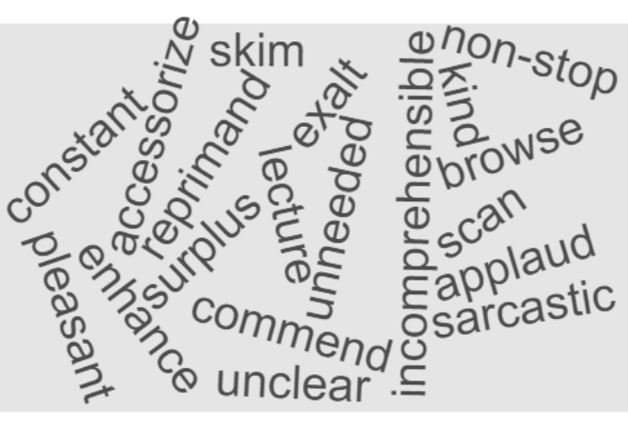

Word | Synonyms
Incessant

Peruse

Sardonic

Cordial
Extol

Superfluous
Upbraid
Inscrutable
Embellish

Organize the above SYNONYMS into the chart. There will be a random number of synonyms per box.

OVER FOR ANTONYMS

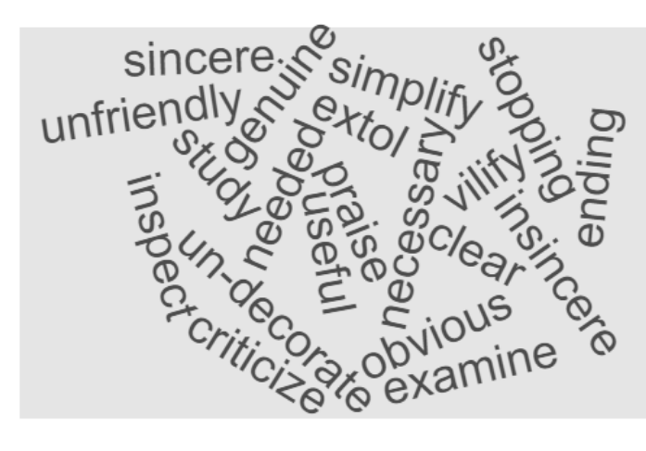
Organize the above ANTONYMS into the chart. There will be a random number of antonyms per box.
Word | Antonyms
Incessant

Peruse

Sardonic

Cordial
Extol

Superfluous
Upbraid
Inscrutable
Embellish

