Dream Speech Analysis-Repetition Name:_______________________________________________

Technique 1: Repetition
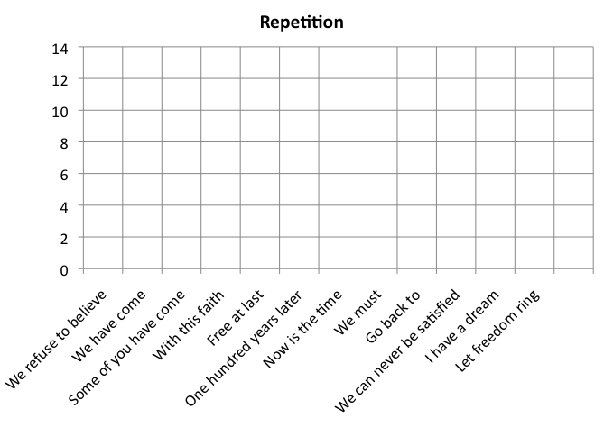
Dr. King used repetition to ___________________________________ ideas & to create ___________________________________ around certain thoughts.

- Were the most frequent words repeated positive or negative? How did King want us to feel after the speech? Why is it important to emphasize those feelings?

- List the phrases that were repeated in relation to time. What message or feeling was Dr. King trying to emphasize by repeating these “time” words?

- Notice that the repeated phrases highlight King’s main ideas, the ideas he wants listeners to remember. What are the main ideas King is trying to express? List them:

Technique 2: Metaphor
- Metaphor is a figure of speech in which a ____________________________________________________________________________ is used to highlight the ____________________________________________ both things share.
- For example:
  - “The houses were phantoms.” (Charles Dickens)
  - Dickens is comparing a __________________________________ to a ___________________________________ to highlight that the house was ________________________________ and _______________________________, just like phantoms.
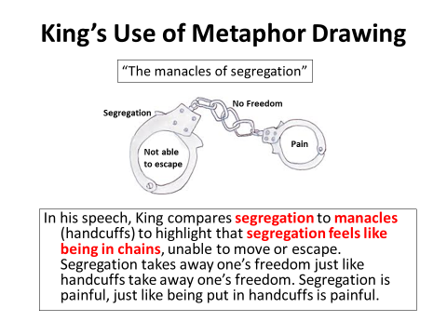

Metaphor:
Drawing:

Dr. King compares _____________________________ (first item) to ________________________________ (second item) in order to highlight that _______________________________(first item) feels like _____________________________________________________
________________________________________________________________________________________________________________________________
____________________________________________________________________________________________________________________________
Metaphor:
Drawing:
Dr. King compares _____________________________ (first item) to ________________________________ (second item) in order to highlight that _______________________________(first item) feels like _____________________________________________________
________________________________________________________________________________________________________________________________
____________________________________________________________________________________________________________________________

Technique 3: Alliteration
- Alliteration is the _________________________________________ of ______________________________________________ in words
- Alliteration gives the piece a song-like quality that makes the speech ________________________________________________.
- It also places emphasis on certain parts:
  - “Five score years ago, a great American, in whose symbolic shadow we stand today…”
  - Civil rights advocates must meet “Physical force with soul force…”
  - Peter Piper picked a peck of pickled peppers…

Technique 4: Counter-Argument
- In this technique, the writer addresses the _______________________________________________ argument.
- It expresses the ______________________________ of a person who ___________________________________ with your opinion or position.
- This gives the writer the chance to respond to the other side’s ________________________________________________________________ before they have finished reading/listening.

Discussion
- What counterargument does King offer those who think racial issues should be given some time to “cool off” or change gradually?

- What counterargument does King offer to those who are tired of fighting?

