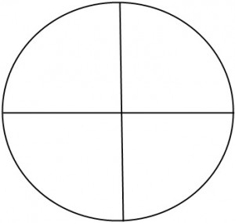 

**Word: ___________________________________**

**Context Clue Sentence:**

**_________________________________________**

**_________________________________________**

**_________________________________________**

**_________________________________________**

**_________________________________________**

**_________________________________________**

**_________________________________________**

**Word: ___________________________________**

**Context Clue Sentence:**

**_________________________________________**

**_________________________________________**

**_________________________________________**

**_________________________________________**

**_________________________________________**

**_________________________________________**

**_________________________________________**

**Example**

**Is**

**Isn’t**

**Non-Example**

**Example**

**Non-Example**

**Isn’t**

**Is**



**Word: ___________________________________**

**Context Clue Sentence:**

**_________________________________________**

**_________________________________________**

**_________________________________________**

**_________________________________________**

**_________________________________________**

**_________________________________________**

**_________________________________________**

**Non-Example**

**Example**

**Isn’t**

**Is**